**Лабораторная работа № 7.**

**Основные понятия теории графов.**

**РЕШИТЬ ЗАДАЧИ:**

Составьте матрицы инцидентности и смежности для следующих графов:

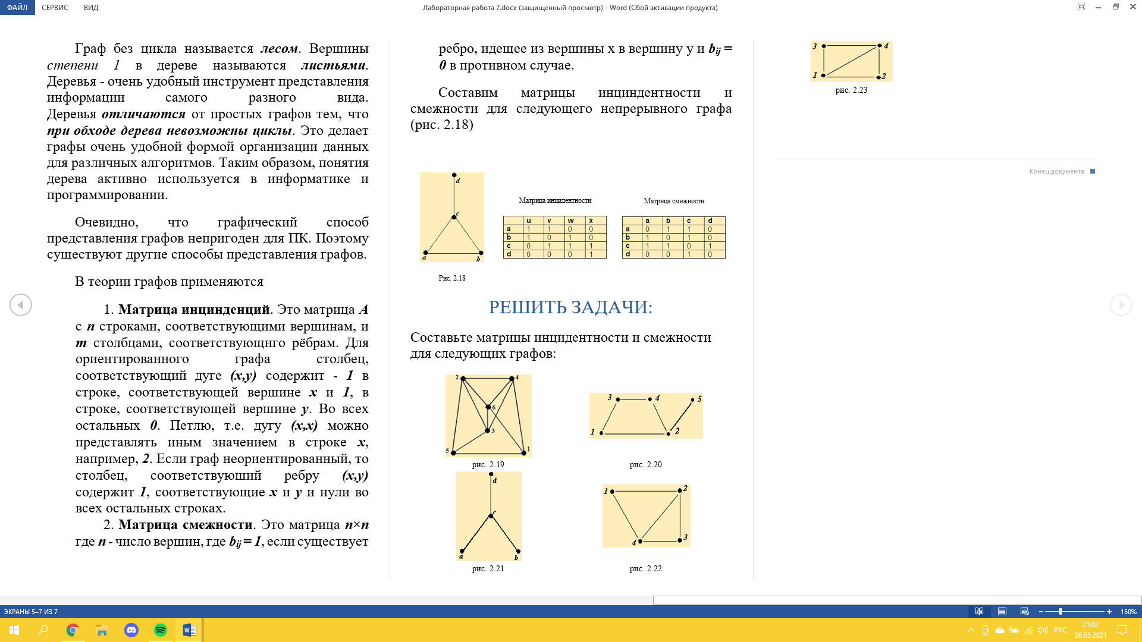 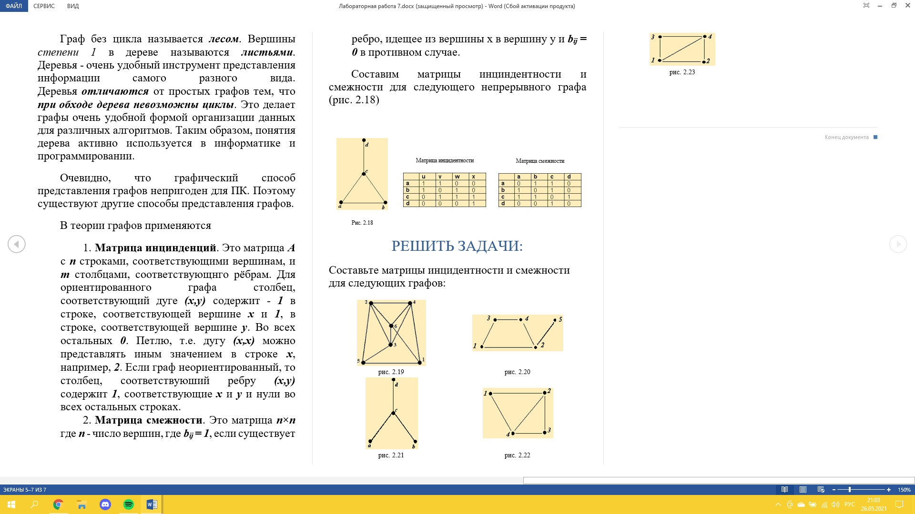

**РЕШЕНИЕ:**

2.19)Матрица инцидентности:

|  |  |  |  |  |  |  |  |  |  |  |  |
| --- | --- | --- | --- | --- | --- | --- | --- | --- | --- | --- | --- |
|  | (1,4) | (1,5) | (1,6) | (2,3) | (2,4) | (2,5) | (2,6) | (3,4) | (3,5) | (3,6) | (4,6) |
| 1 | 1 | 1 | 1 | 0 | 0 | 0 | 0 | 0 | 0 | 0 | 0 |
| 2 | 0 | 0 | 0 | 1 | 1 | 1 | 1 | 0 | 0 | 0 | 0 |
| 3 | 0 | 0 | 0 | 1 | 0 | 0 | 0 | 1 | 1 | 1 | 0 |
| 4 | 1 | 0 | 0 | 0 | 1 | 0 | 0 | 1 | 0 | 0 | 1 |
| 5 | 0 | 1 | 0 | 0 | 0 | 1 | 0 | 0 | 1 | 0 | 0 |
| 6 | 0 | 0 | 1 | 0 | 0 | 0 | 1 | 0 | 0 | 1 | 1 |

Матрица смежности:

|  |  |  |  |  |  |  |
| --- | --- | --- | --- | --- | --- | --- |
|  | 1 | 2 | 3 | 4 | 5 | 6 |
| 1 | 0 | 0 | 0 | 1 | 1 | 1 |
| 2 | 0 | 0 | 1 | 1 | 1 | 1 |
| 3 | 0 | 1 | 0 | 1 | 1 | 1 |
| 4 | 1 | 1 | 1 | 0 | 0 | 1 |
| 5 | 1 | 1 | 1 | 0 | 0 | 0 |
| 6 | 1 | 1 | 1 | 1 | 0 | 0 |

2.20)Матрица инцидентности:

|  |  |  |  |  |  |
| --- | --- | --- | --- | --- | --- |
|  | (1,2) | (1,3) | (2,4) | (2,5) | (3,4) |
| 1 | 1 | 1 | 0 | 0 | 0 |
| 2 | 1 | 0 | 1 | 1 | 0 |
| 3 | 0 | 1 | 0 | 0 | 1 |
| 4 | 0 | 0 | 1 | 0 | 1 |
| 5 | 0 | 0 | 0 | 1 | 0 |

Матрица смежности:

|  |  |  |  |  |  |
| --- | --- | --- | --- | --- | --- |
|  | 1 | 2 | 3 | 4 | 5 |
| 1 | 0 | 1 | 1 | 0 | 0 |
| 2 | 1 | 0 | 0 | 1 | 1 |
| 3 | 1 | 0 | 0 | 1 | 0 |
| 4 | 0 | 1 | 1 | 0 | 0 |
| 5 | 0 | 1 | 0 | 0 | 0 |

2.21) Матрица инцидентности:

|  |  |  |  |
| --- | --- | --- | --- |
|  | (a,c) | (b,c) | (c,d) |
| a | 1 | 0 | 0 |
| b | 0 | 1 | 0 |
| c | 1 | 1 | 1 |
| d | 0 | 0 | 1 |

Матрица смежности:

|  |  |  |  |  |
| --- | --- | --- | --- | --- |
|  | a | b | c | d |
| a | 0 | 0 | 1 | 0 |
| b | 0 | 0 | 1 | 0 |
| c | 1 | 1 | 0 | 1 |
| d | 0 | 0 | 1 | 0 |

2.22) Матрица инцидентности:

|  |  |  |  |  |  |
| --- | --- | --- | --- | --- | --- |
|  | (1,2) | (1,4) | (2,3) | (2,4) | (3,4) |
| 1 | 1 | 1 | 0 | 0 | 0 |
| 2 | 1 | 0 | 1 | 1 | 0 |
| 3 | 0 | 0 | 1 | 0 | 1 |
| 4 | 0 | 1 | 0 | 1 | 1 |

Матрица смежности:

|  |  |  |  |  |
| --- | --- | --- | --- | --- |
|  | 1 | 2 | 3 | 4 |
| 1 | 0 | 1 | 0 | 1 |
| 2 | 1 | 0 | 1 | 1 |
| 3 | 0 | 1 | 0 | 1 |
| 4 | 1 | 1 | 1 | 0 |

2.23) Матрица инцидентности:

|  |  |  |  |  |  |
| --- | --- | --- | --- | --- | --- |
|  | (1,2) | (1,3) | (1,4) | (2,4) | (3,4) |
| 1 | 1 | 1 | 1 | 0 | 0 |
| 2 | 1 | 0 | 0 | 1 | 0 |
| 3 | 0 | 1 | 0 | 0 | 1 |
| 4 | 0 | 0 | 1 | 1 | 1 |

Матрица смежности:

|  |  |  |  |  |
| --- | --- | --- | --- | --- |
|  | 1 | 2 | 3 | 4 |
| 1 | 0 | 1 | 1 | 1 |
| 2 | 1 | 0 | 0 | 1 |
| 3 | 1 | 0 | 0 | 1 |
| 4 | 1 | 1 | 1 | 0 |